A kind of linear structure binary image segmentation method

Yexiu Fen Ya-Jun Yang
(Harbin Engineering University, Harbin, Heilongjiang Province, 150001)

Abstract: In many medical imaging applications, the extraction of linear structure like vessel capillaries in vascular images or axon and dendities in neuronal images is of important significance.Since the extraction of linear structure in medical image using global threshold algorithm accompanies with the problem of linear discontinuities and serious noise confusion. This paper proposes a connected domain based binary segmentation method for linear structure in medical images, which takes full advantage of the linear smoothing and enhance features of steerable filter, as well as the strength of better linear structure connectivity when processing images with smooth boundary using local threshold segmentation method. Finally, we proposed a connected-domain based image binarization segmentation method for linear structure. The corresponding experimental results show that the methods proposed in this paper can guarantee line connection characteristics well with inhibited noise greatly.
Keywords: linear structure; Steerable filter; thresholding; connected domain

1 Introduction
The linear structure and other characteristics of the image, such as the retina, capillaries and nerve axons and dendrites, have important significance in medicine image segmentation. There is no general segmentation algorithm for the linear structure of the medical image since the blood vessels and nerves axon dendritic structure is complex, uneven intensity distribution and density factors change. Typical algorithms, such as region growing algorithm [1,2,3], matched filtering algorithm[4,5] and the level set algorithm[6] have been successfully applied in image segmentation of blood vessels, however, this segmentation does not fits for those neural images with axons and dendrites which have weak connectivity, uneven gray-level and unconspicuous tubular structures.
T.Freeman[7] summaries of the mathematical theory and design algorithms of the steerable filters. M.Jacob[8] proposed the design principle of steerable filter based on Canny similarity criterion. The steerable filter algorithm based on Gaussian kernel can be a good smooth and enhancement for the image with linear structure. Thresholding algorithm is the basic algorithm of binary image segmentation, which can be divided into global threshold and local threshold. However, common global thresholding algorithms such as Otsu algorithm [9], can not maintain the connectivity of the linear structure very well. Local thresholding algorithms such as NiBlack algorithm [10, 11], have been effective for the segmentation of text-based image, however, for non-text-based image segmentation, this kind of algorithm will cause a large number of binary noise.
This paper designs several segmentation methods based on connected domain to extract the linear structure in medical images, which takes full advantage of the linear smoothing and enhance features of steerable filter based on Gaussian kernel, as well as the strength of better linear structure connectivity when processing images with smooth boundary using local threshold segmentation method. Section II introduces the steerable filter algorithm and points out the specific function we select. Section III presents the design principles of the proposed algorithm in this
paper. By the experiments compared with the level set algorithm, K-means algorithm and etc in section III, we make a summary in section IV.

2 steerable filters
In summarizing the design principle of steerable filters, paper[7] points out that the steerable filter is based on the function of polar coordinates in the form of Fourier series expansion. The purpose of this process is to express the steerable filter as the linear combination of the arbitrary direction of the basic filter function.由于卷积的运算也是一种线性运算，因此将通过一次滤波响应后，再用一组基滤波器函数的线性组合来表示，这样就避免了很多重复的卷积运算，减少了运算量，提高了运算效率。
Steerable filter is generally expressed as follows:
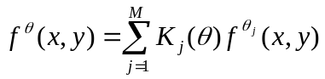（1）
Among them,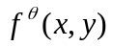 is the steerable filter and is the direction 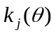is the J-th interpolation function, M is the number of basis functions, 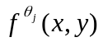 is the basic filter and is J-th group function direction.
Interpolation function normally follows the following constraints:
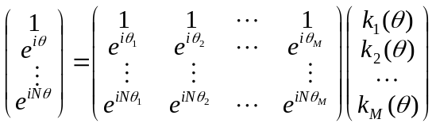(2)
The derivative of Gauss's function can be expressed as a circularly symmetric window function and a polynomial multiplication, so often using the method based on Gaussian function to construct the steerable filter.
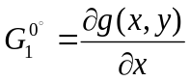 （3）
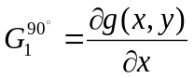 （4） 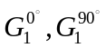are 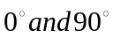 as is functions direction, then by a linear combination of these two basis functions can be determined arbitrarily Function direction. Such as
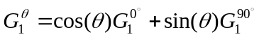 （5）
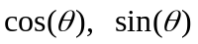Corresponding interpolation function.
The experiments of this paper for the steerable filter are based on the second derivative Gaussian filter, which normalized Gaussian function as follows:
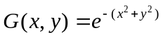 （6）
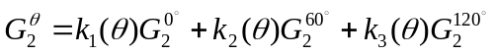 （7）
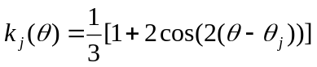 （8）
Figure 1 shows the filtering effect of the steerable filter algorithm based on the Gaussian kernel. From Figure 1(b),This has important implications for the further extracted to the linear structure of the medical images.

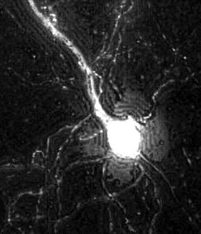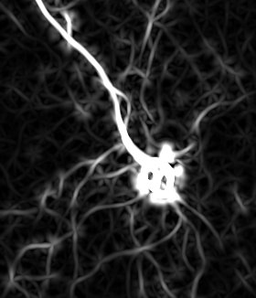
Original image (B) second-order Gaussian filter to enhance controllability
Figure 1 Steerable second-order Gaussian filter

3 Our Approach
3.1 thresholding algorithm effectiveness analysis
Thresholding algorithm is generally divided into global thresholding and local thresholding. Global thresholding method is only to choose a fixed threshold T for an image, such as Otsu algorithm, maximum entropy method and gray expectation method. Local thresholding method is divided into thresholding segmentation method based on a block and neighborhood-based segmentation algorithm,such as NiBlack algorithm, Sauvola algorithm and Feng algorithm, these algorithms have been effectively used for text-based images.
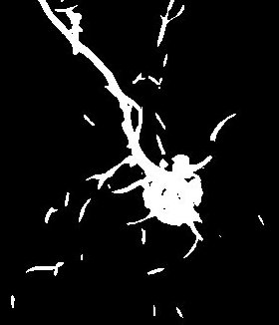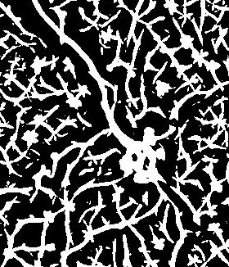
(C) Figure 1 (b) of Otsu thresholding (D) Figure 1 (b) of NiBlack thresholding
Figure 2 threshold image processing effects
As shown in Figure 2 which shows the result of the Otsu global threshold and the local threshold processing of NiBlack algorithm for Figure1(b), we found that global thresholding algorithm cannot guarantee the connectivity of the linear structure, which is not conducive to the later image reconstruction. The local thresholding method can guarantee the connectivity of the linear structure, but the algorithm causes a large number of false linear structure information. Therefore, combining the traditional Otsu algorithm and NiBlack algorithm, firstly, to process the image with linear structure by the steerable filter algorithm, secondly, Otsu algorithm and NiBlack algorithm are used for threshold segmentation of the processed image.By the statistics of connected domain of the binary image processed by the NiBlack segmentation algorithm, regarding the results of the binarization segmentation of Otsu algorithm as a “referee" to decide which connected domain of NiBlack segmentation should “leave or stay”. The specific algorithm is as below.
3.2 NiBlack linear structure extraction processing image
2.2.1. Binary connected domain statistics and tagging images
In this paper, the depth first traversal(DFS) algorithm is used to mark the connected domain of the current image after the NiBlack algorithm. Because the function recursion may cause the stack space to overflow, we set up the longest connected domain 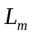 500 pixel points in the experiment of this paper .
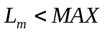 （9） Among them, is the longest length of the connected domain allowed to mark, MAX is the maximum permissible value to cause a stack overflow.
In this experiment, the image to be marked is binary image and the marked pixels is foreground (pixel value is 255). In the marking process, to make statistics through the establishment of a one-dimensional array and the subscript representing the marked value and the value of the one-dimensional representing the length of the connected domain. In order to make the array subscript corresponding to the marking result, the binary image(0,255) is converted to the binary image(0, 1) which will be marked with the pixels with value 1 and regard 2 as the starting number of marking.As shown in Figure 3.
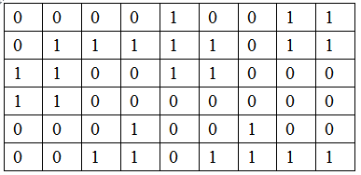
(A) NiBlack thresholding
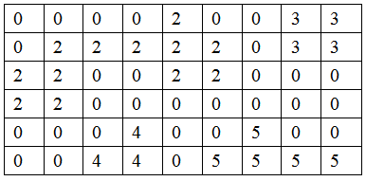
(B) (a) connected component labeling
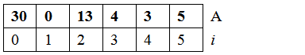
(C) (b) length connected domain statistics
Figure 3 connected component labeling Statistical Process
3.2.2. The number of connected domain statistics
Otsu thresholding segmentation algorithm cannot maintain the connectivity of the linear structure image, but this method can basically separate foreground from background.To take advantage of this feature, this paper counts the pixel number of foreground of Otsu image corresponding to the marked image(Figure 3(b)).
As shown in Figure 4 (C), to create a one-dimensional array with same length and same subscript meaning corresponding to the marked value, comparing with the array in Figure 3(c). 扫描Otsu阈值分割图像，在像素值f(x,y)为255点位置处（在图4示例中已经用1表示），将被标记图像对应位置标记值作为下标访问位置元素对应一维数组元素值加1。
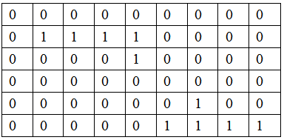
(A) Otsu thresholding
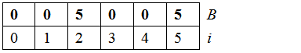
(B) by the (a) Figure chart (2) (b) Figure connected domain
Figure 4 Otsu highlights landed connected domain statistical process
3.2.3 connected domains "fate" and "determination"
Through step 1 and step 2, we obtain two one-dimensional arrays, which are labeled by connected domain as the index. An array of statistics for the length of the connected domain denoted as A (I) and another array of statistics denoted as B(i) counting the foreground pixel number of Otsu image corresponding to the marked connected domain image. The distribution of the length of the connected domain of the NiBlack image is reflected by array A(i). 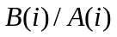 can judge the degree of confidence of the value of array A(i). Since the value 2 is selected as the starting value of the connected domain mark, 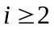 just as below.
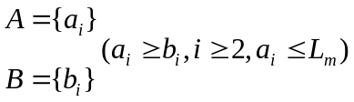 (10)
Since 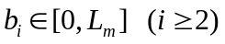,i is the labeled value of connected domain, creating histogram 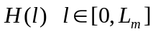 for the array B(i).
- Expectation approach
Referring the concept of histogram in gray image threshold segmentation,we regard array B as “an image” with n pixels and 0~ gray level to build probability density histogram as below,
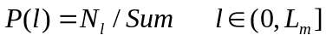 (11)
image segmentation.
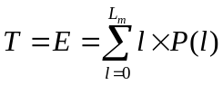 (12)
- Otsu threshold for the selected communication field
By referring the concept of Otsu algorithm in gray image segmentation,we get the global connected domain threshold 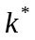. When the histogram is divided into two groups by a threshold, the value that can make the variance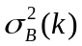 between the two groups become the biggest will be chosen as the connected domain threshold . as below.
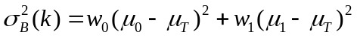 (13)
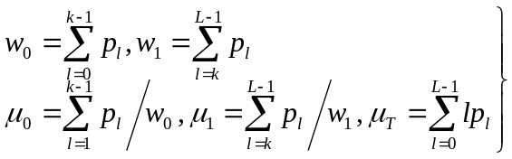(14)

- Ratios
Due to the A and B array can indirectly reflect the length properties and confidence attributes of the connected domains. 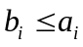, assume
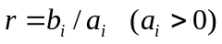 (15)
If r is less than 0.3 (variable parameter), then discard the corresponding connected domain, otherwise keep reserved.
4 Experiment and Analysis
In the last two chapters, we discuss the steerable filter algorithm based on Gaussian function and the proposed threshold segmentation algorithm for the linear structure segmentation of medical images. Contrast experiments will be presented in this chapter.
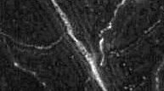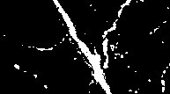
(A) Original image (B) Otsu thresholding
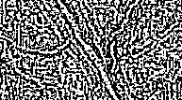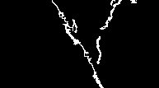
(C) NiBlack thresholding (D) Our approach
Figure 5 without a controllable filter pretreatment binary renderings
Figure 5 shows the effect of threshold segmentation without the preprocessing by steerable filter. From Figure 5(c), due to the noise interference, we can see that it causes NiBlack algorithm cannot maintain the connectivity on the linear structure.
Therefore, our algorithm for not after pretreatment of steerable filter with noise of original image is not very good extract the linear structure
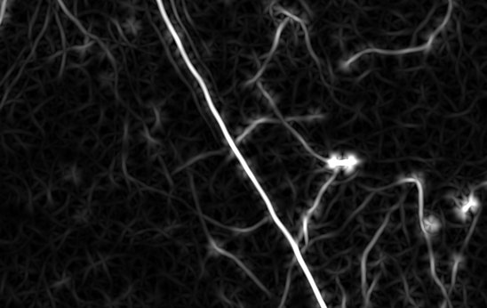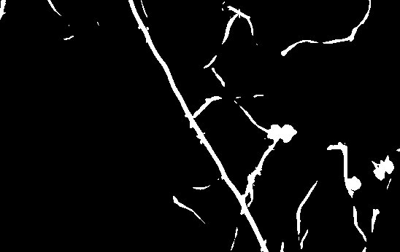
(A) steerable filter (B) (a) Otsu thresholding results
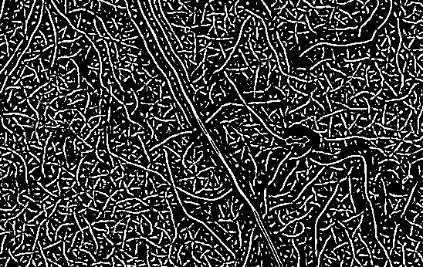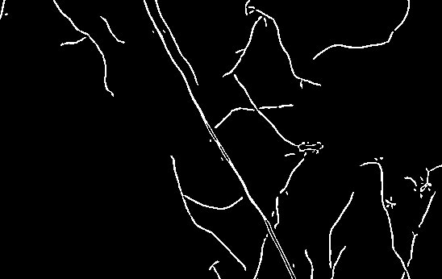
(C) (a) NiBlack thresholding (D) the expected Law article
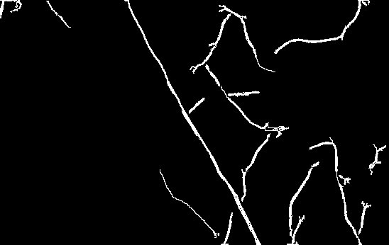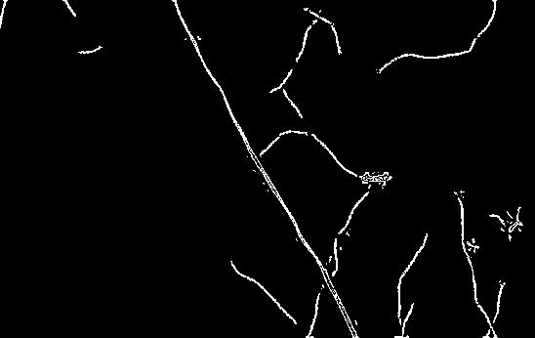
(E) This article Otsu law (F) ratio method herein
Figure 6 after binarization controllable filter pretreated segmentation renderings
Figure 6 shows the effect of the threshold segmentation of the image processed by the steerable filter. After the preprocessing of steerable filter based on Gaussian function, the linear structure is more smooth and the particle noise is well inhibited. It can be seen that our algorithm can well extract the linear structure of Figure 6 (c) just as shown in Figure 6(D,E,F).
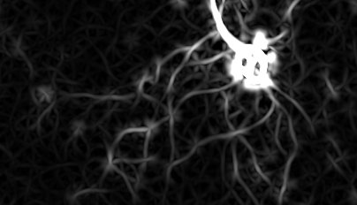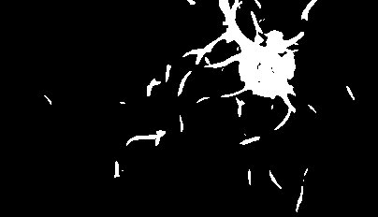
(A) controllable filter (B) (a) Otsu thresholding results
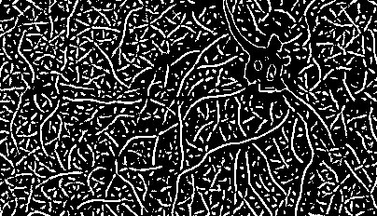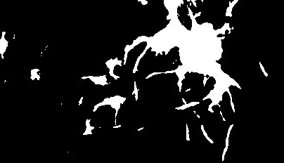
(C) (a) NiBlack thresholding (D) (a) level set segmentation
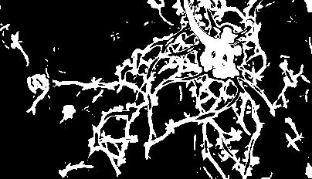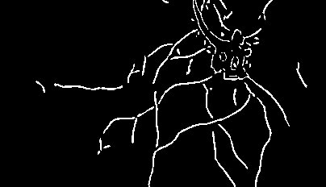
(E)(a) K-means segmentation (F) (a) algorithm
Figure 6 Experimental comparison of different methods

5 Conclusion
According to the noise sensitive characteristics for the linear structure segmentation of the universal threshold segmentation algorithm. In this paper, we use the steerable filter algorithm based on Gauss kernel to preprocess the image. In view of the traditional thresholding method, the linear structure of the image can not be well maintained for the global thresholding algorithm such as Otsu algorithm and it will cause a large number of noise for local threshold algorithm such as NiBlack algorithm. his paper designs several segmentation methods based on connected domain to extract the linear structure in medical images, which takes full advantage of the linear smoothing and enhance features of steerable filter based on Gaussian kernel, as well as the strength of better linear structure connectivity when processing images with smooth boundary using local threshold segmentation method.After experiment, our algorithm can segment the linear structure in the medical image well.
Reference
- Baby, Anju Soosan, and K. Balachandran. "A parallel approach for region-growing segmentation." Computer Engineering and Applications (ICACEA), 2015 International Conference on Advances in. IEEE, 2015.
- Abdelsamea, Mohammed M. "An automatic seeded region growing for 2d biomedical image segmentation." arXiv preprint arXiv:1412.3958 (2014).
- Yi, Jaeyoun, and Jong Beom Ra. "A locally adaptive region growing algorithm for vascular segmentation." International Journal of Imaging Systems and Technology 13.4 (2003): 208-214.
- Djima, Karamatou A. Yacoubou, et al. "Detection of anomaly in human retina using Laplacian Eigenmaps and vectorized matched filtering." SPIE Medical Imaging. International Society for Optics and Photonics, 2015.

- Zhang, Bob, et al. "Retinal vessel extraction by matched filter with first-order derivative of Gaussian." Computers in biology and medicine 40.4 (2010): 438-445.
- Pang, Jincheng. The Level Set Method and Its Applications in Medical Image Analysis. Diss. TUFTS UNIVERSITY, 2015.
- Freeman, W. T., & Adelson, E. H. (1991). The design and use of steerable filters. IEEE Transactions on Pattern Analysis & Machine Intelligence, (9), 891-906.
- Jacob, M., & Unser, M. (2004). Design of steerable filters for feature detection using canny-like criteria. Pattern Analysis and Machine Intelligence, IEEE Transactions on, 26(8), 1007-1019.
- Jiang, Hui-Yan, Yue-peng Si, and Xing-gang Luo. "Medical Image Segmentation Based on Improved Ostu Algorithm and Regional Growth Algorithm." JOURNAL-NORTHEASTERN UNIVERSITY NATURAL SCIENCE 27.4 (2006): 398.
- Khurshid, Khurram, et al. "Comparison of Niblack inspired Binarization methods for ancient documents." IS&T/SPIE Electronic Imaging. International Society for Optics and Photonics, 2009.
- Bhuvaneswari, S., and T. S. Subashini. "Automatic Detection and Inpainting of Text Images." International Journal of Computer Applications (0975–8887) Volume (2013).

